DOKUZ EYLUL UNIVERSITY
ENGINEERING FACULTY
DEPARTMENT OF COMPUTER ENGINEERING

CME1251 PROJECT BASED LEARNING – I
FINAL REPORT
PROJECT – I

SHAPER

by
Talha Mustafa Antep
Ziya Sharifli
Irem Tekin
Ezgi Tan

Lecturers
Dr.Ozlem Oztürk
Dr.Meltem Yıldırım

IZMIR
04.11.2022

CHAPTER ONE
PROGRESS DESCRIPTION
We met our friends in the group. We have decided what path to take. We learned how to make a flowchart in the first week and gathered after the lesson and made a flowchart. In the second week, we started learning C# and made a coordinate plane in Visual Studio. In the third week, we learned the If-Else structure and gradually started to complete our codes. When the codes started to take their final form,we decoupled and discussed our mistakes among ourselves. We have put out the most neat and short code.In the fourth week, we prepared our poster and PowerPoint presentation.

CHAPTER TWO
TASK SUMMARY

Completed Tasks
Talha Mustafa Antep: He gave Flowchart an idea.He created the coordinate plane.He wrote a code that works flawlessly using the If-Else structure.
Ziya Sharifli: He gave Flowchart an idea.He prepared the PowerPoint presentation.
Irem Tekin: She gave Flowchart an idea. She came up with the idea of changing the If-Else structure in the code. She made the poster.
Ezgi Tan: She prepared the final version of the flowchart. She gave a lot of ideas about the code.She helped edit the poster.

Incomplete Tasks: Reasons and Explanations
Talha Mustafa Antep:We completed all of our tasks.

Ziya Sharifli:We completed all of our tasks.

Irem Tekin:We completed all of our tasks.

Ezgi Tan:We completed all of our tasks.

Additional Improvements to the Project
Talha Mustafa Antep: Collected in one code by connecting If-Elses with or.So there were fewer lines of code.We have restricted the value or structure given to point A.Thus, we prevented the A value from being given incorrectly.In addition to Manhattan Distances, we made an accurate calculation by adding the Euclidean correlation.

Ziya Sharifli: We have shortened our PowerPoint presentation.We made it more understandable.

Irem Tekin: Collected in one code by connecting If-Elses with or.So there were fewer lines of.We have restricted the value or structure given to point A.Thus, we prevented the.We have made it more useful by adding a QR code to our poster.We have shortened our PowerPoint presentation.We made it more understandable.

Ezgi Tan:The first version of FlowChart has been changed.A more accurate FlowChart has been revealed.We have restricted the value or structure given to point A.Thus, we prevented the A value from being given incorrectly.We have made it more useful by adding a QR code to our poster.We have shortened our PowerPoint presentation.We made it more understandable.

CHAPTER THREE
EXPLANATION of algorıthms

Screenshots
At first, we were writing the if structure one by one. In this case, we have obtained close to 500 lines of code. We then obtained close to 360 lines of code using the if structure or link.
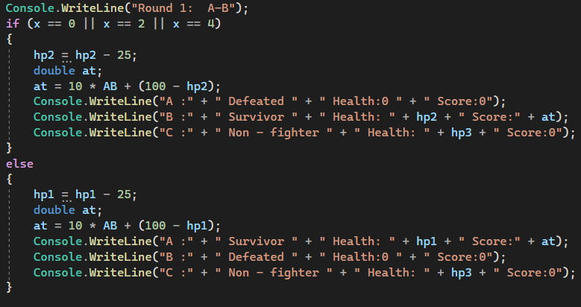

Functions
1-Console.WriteLine
2-Convert.ToDouble
3-rd.Next
4-If-Else
5-Console.SetCursorPosition
6-Math.Sqrt
7-Math.Pow
8-Math.Abs
9-Console.ReadLine

Algorithms and Solution Strategies
Talha Mustafa Antep: When I located archers, I created a equation to show their location on the coordinate plane. I used
(25 + (x*2) , 17 + (y*-1)) for x and y axises.

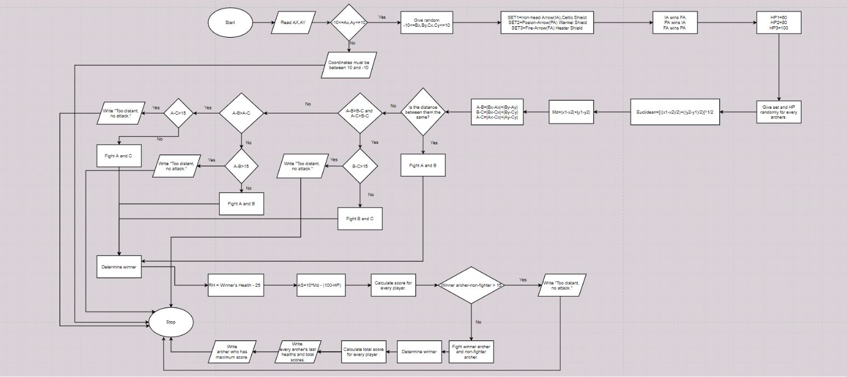

Ziya Sharifli:We used dots(.) and dashes(-) to create the coordinate plane.

Irem Tekin: Since we didn't know if else, She got help from the internet. We used dots(.) and dashes(-) to create the coordinate plane.

Ezgi Tan: Since we don't use flowchart loops, She had to use too many conditions (diamonds).

CHAPTER FOUR
PROBLEMS ENCOUNTERED

Talha Mustafa Antep: We used the missing equation to the decipher the distance between them. We used the Euclidean relation for the new equation. With the if-elses we used, our code became unnecessarily long. The code was jumping because of a bracket we forgot in else, the war was not ending. We misspelled the archers' title in Round 2. We could not limit the coordinates of A because we used the <, > signs in reverse. The SetCursorPosition equation was incorrect because we added a line of the decode. We have made changes to the equation.
Ziya Sharifli: …

Irem Tekin: With the if-elses we used, our code became unnecessarily long. We misspelled the archers' title in Round 2. We could not limit the coordinates of A because we used the <, > signs in reverse. The SetCursorPosition equation was incorrect because we added a line of the decode. We have made changes to the equation.

Ezgi Tan: The code was jumping because of a bracket we forgot in else, the war was not ending. We misspelled the archers' title in Round 2. We could not limit the coordinates of A because we used the <, > signs in reverse. The SetCursorPosition equation was incorrect because we added a line of the decode. We have made changes to the equation.

CHAPTER FIVE
conclusıon
We learned how to make the flowchart. We learned how to assign a random sets and healths. We have made the code shorter and more accurate by using if-else where we need to use conditions. We wrote the coordinate plane correctly. We have shown the archers in the coordinate plane using SetCursorPosition. We wrote Euclid and Manhattan Distance using mathematical correlations. We found the one with the least distance between the 3 archers and made them fight so that we finished Round 1. In Round 2, we made the survivor and non-fighter archers fight and determined the winner of the game. We calculated the maximum score using a mathematical correlation. And we printed it all on the screen.

REFERENCES
https://learn.microsoft.com/enus/dotnet/api/system.console.setcursorposition?view=net-6.0

https://www.draw.io/connect/office365/index.html

https://app.qr-code-generator.com/manage/?aftercreate=1&count=3&login=1

https://medium.com/@canerbasat/if-else-kosul-yapisi-90e7475c6249

https://www.canva.com/design/DAFQVXN7v1Q/qRy7I5nzywP4AvZymou2oQ/edit?utm_content=DAFQVXN7v1Q&utm_campaign=designshare&utm_medium=link2&utm_source=sharebutton#

AppendIx A
Poster/Web page of the Project
(Give Picture Of Poster Or Some Key Screens From Web Page.)
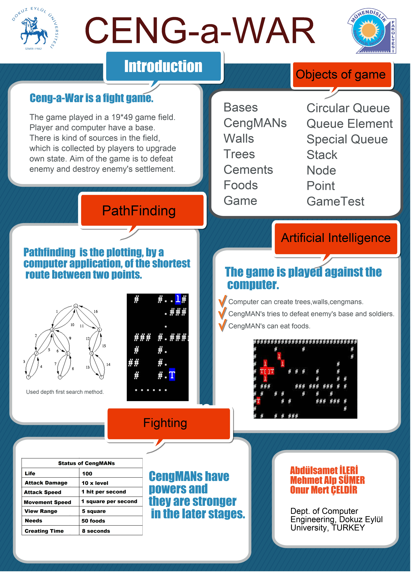
Figure A-1 Example poster.
AppendIx B
Code of the Project
(Give clear, indented, fully commented code of your project. Give the most important code parts of your project.)

